**################OPEN PBS#####################**

**Portable Batch System**

—------------------------------------------------------------------------------------------------------------

The Portable Batch System (PBS) system is **designed to manage the distribution of batch jobs and interactive sessions across the available nodes in the cluster**.

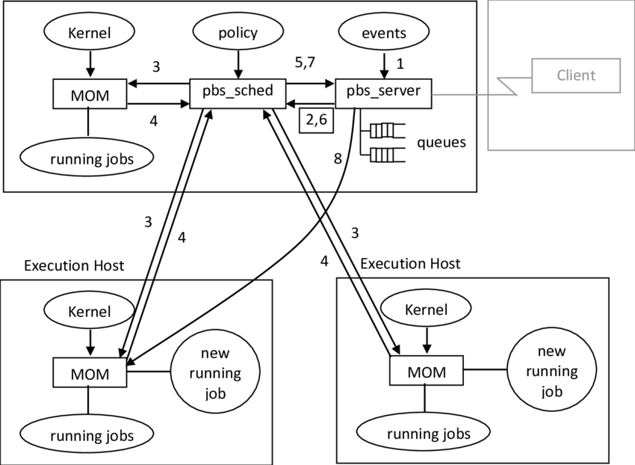

MOM-Machine Oriented Miniserver

**Prerequisite**

systemctl disable firewalld

vi /etc/selinux/config

nano /etc/hosts

**SERVER**

* yum install -y gcc make rpm-build libtool hwloc-devel \

libX11-devel libXt-devel libedit-devel libical-devel \

ncurses-devel perl postgresql-devel postgresql-contrib python3-devel tcl-devel \

tk-devel swig expat-devel openssl-devel libXext libXft \

autoconf automake gcc-c++

* yum install -y expat libedit postgresql-server postgresql-contrib python3 \

> sendmail sudo tcl tk libica

* wget <https://github.com/openpbs/openpbs/archive/refs/tags/v20.0.1.tar.gz>
* mv v20.0.1.tar.gz openpbs-20.0.1.tar.gz
* rpmbuild -ta openpbs-20.0.1.tar.gz
* yum install libtool-ltdl-devel
* rpmbuild -ta openpbs-20.0.1.tar.gz
* Cd /root/rpmbuild/RPMS/x86_64/
* Vi /etc/pbs.conf
* 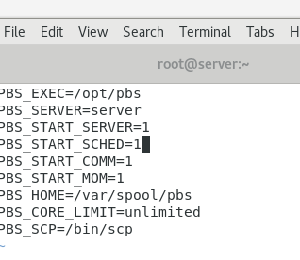
* /etc/init.d/pbs start
* 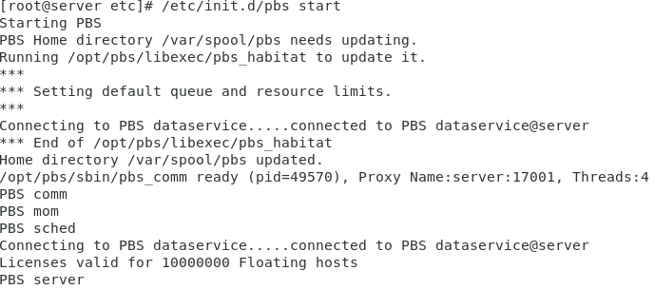
* . /etc/profile.d/pbs.sh → to set the environment in systempath
* qstat →Squeue
* qsub →Sbatch
* qdel →Scancel
* qsub -I →login to user (su - hpcsa) to submit the job

**Now add node**

* rsync /root/rpmbuild/RPMS/x86_64/openpbs-execution-20.0.1-0.x86_64.rpm root@node1:/root
* rsync /root/rpmbuild/RPMS/x86_64/openpbs-execution-20.0.1-0.x86_64.rpm root@node2:/root

**On node1**

* rpm -ivh openpbs-execution-20.0.1-0.x86_64.rpm
* yum install hwloc-libs
* yum install libhwloc.so.5* -y
* yum install libpython3.6m.so.1.0* -y
* yum install libtcl8.5.so* -y
* yum install libtk8.5.so* -y
* yum install python3* -y
* rpm -ivh openpbs-execution-20.0.1-0.x86_64.rpm
* vi /var/spool/pbs/mom_priv/config

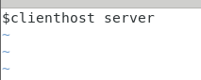

* vi /etc/pbs.conf

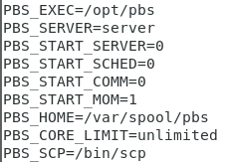

* . /etc/init.d/pbs start
* . /etc/profile.d/pbs.sh

**On node2**

**Same as node1**

**On Server**

* vi /var/spool/pbs/server_priv/nodes



* qmgr -c "create node node1"
* qmgr -c "create node node2"
* . /etc/profile.d/pbs.sh
* pbsnodes -a → to see the active nodes.

